Report on the
Eötvös 100 Exhibition held at the Assembly of the European Geoscience Union (EGU)
Vienna, 8-12 April, 2019

The EGU General Assembly was organized between 2019.04.08-12 in Vienna, where a commemorative exhibition was displayed on the occasion of the Eötvös anniversary. At the exhibition booth posters were shown about the life and works of Loránd Eötvös, illustrated by a selection of the greatest stereoscopic photographs made by Eötvös. The highlight of the exhibition was undoubtedly the original double torsion balance that was transported to the venue from the Geodetic and Geophysical Institute, Sopron.
The exhibition was greatly popular all week long among the more than 15 000 participants of the assembly. Many of the visitors - mostly from the field of geophysics and geodesy - were mainly attracted by the torsion balance. Some of them knew only the name of Eötvös, others knew very well his work, but we even had some visitors who were really touched to examine the more than hundred year old instrument - “I’ve been teaching this for 20 years, but never seen one!”
The shiny brass instrument attracted a lot of visitors also from other fields of sciences, even those were curious to understand it who have never heard about Eötvös. The 3D photos were popular even among children who accompanied their parents at the conference.
The first day of the conference coincided with the actual day of the anniversary, which gave us opportunity for a short live on-site reporting from Vienna to the commemorative celebration held at the Hungarian Academy of Sciences in Budapest. During this reporting our special guests were Prof. Sierd Cloetingh, president of Academia Europaea and Honorary Member of Hungarian Academy of Sciences, and Prof. Jonathan Bamber, president of EGU.

Beszámoló az
Európai Földtudományi Unió (EGU) „Eötvös 100” kiállításáról (Bécs, 2019. április 8-12.)

2019. április 8-12 között került megrendezésre az EGU (European Geosciences Union) éves közgyűlése Bécsben, amelyen a jeles évforduló alkalmából egy Eötvös Loránd-emlékkiállítással vettünk részt. A kiállításon posztereken keresztül ismerkedhettek meg az érdeklődök Eötvös életének és munkásságának legfontosabb állomásaival, és 3D-szemüvegen át szemlélhették Eötvös eredeti sztereofotóinak anaglif változatát. A kiállítás fénypontja a soproni Geodéziai és Geofizikai Intézetből a helyszínre szállított eredeti Eötvös-féle kettős inga volt.
A konferencia több mint 15 000 résztvevője egész héten át állandó érdeklődést tanúsított az emlékkiállítás iránt. A látogatók egy része - többnyire geofizikusok és geodéták - elsősorban az inga iránt érdeklődött: volt, aki csak névről ismerte Eötvöst, volt, aki pontosan ismerte a munkásságát, de olyanok is akadtak, akik szinte elérzékenyülve járták körül a több mint százéves műszert - “Már több mint 20 éve tanítom, de még sosem láttam!”
Az embermagasságú csillogó rézműszer rengeteg érdeklődőt vonzott az olyan szakterületek képviselői közül is, akik körében kevésbé cseng ismerősen Eötvös neve. A látványos 3D képek pedig még a szüleiket elkísérő kisgyerekek körében is igen népszerűek voltak.
A konferencia nyitónapja éppen egybeesett a 100 éves évforduló pontos napjával, így lehetőség nyílt egy rövid élő helyszíni tudósításra az április 8-án az MTA székházában tartott ünnepség keretén belül. A bejelentkezés során a vendégünk volt Prof. Sierd Cloetingh, az Academia Europaea elnöke, az MTA tiszteleti tagja, és Prof. Jonathan Bamber, az EGU elnöke. Az elhangzott gondolataik a következőkben olvashatók.

“I would like to thank the Hungarian Academy of Science for bringing the exhibit of Roland's work to the EGU General Assembly. This is the largest geoscience meeting in Europe covering all aspects of the discipline. We have 22 scientific divisions and, while many of the geoscientists working on the diverse topics we cover may not be familiar with Roland Eötvös’s pioneering work, so much of what we do relies on it. I am a glaciologist by background but much of what I do uses geodetic techniques that require accurate geodetic datums and an understanding the Earth's gravity field and so even in my own discipline, his contributions are being felt over century after he made them.
We thank you for choosing EGU as a venue for highlighting his outstanding contribution to geophysics and wish you a successful centennial celebration of his life and works.”

Jonathan Bamber (President/Elnök, EGU)
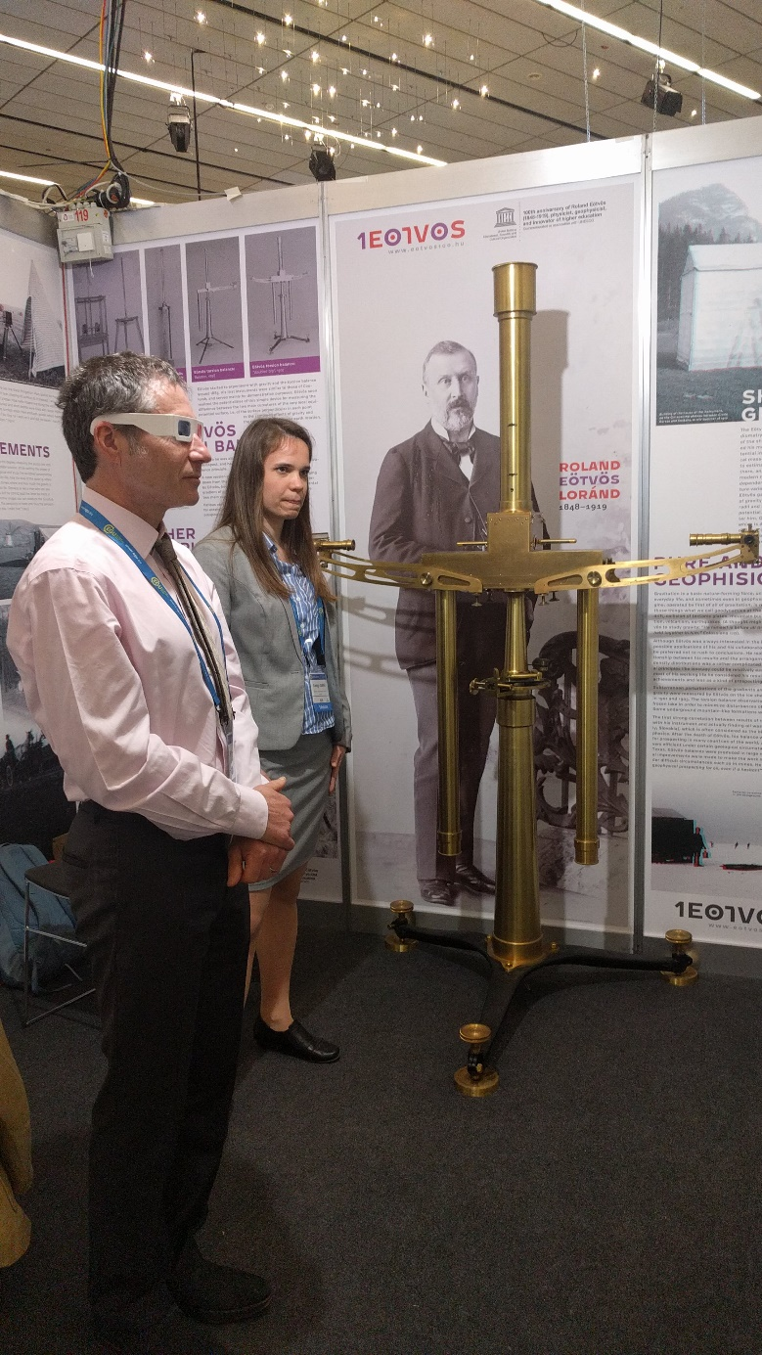
Jonathan Bamber megtekinti a kiállítást / Jonathan Bamber at the exhibition
“Eotvos was one of the great pioneers in geoscience. At this conference of the European Geosciences Union (EGU), attended by 16,000 participants, including many young researchers, we all realize that we are standing on the shoulders of pioneers such as Lorand Eotvos. 100 years ago in 1919 was also a landmark in the gosciences with the foundation of the International Union of Geophysics and Geodesy (IUGG), a field to which Eotvos contributed so much. It is most fitting that the Hungarian Academy of Sciences is present this year with this nice exhibition both at the EGU and IUGG conferences in respectively Vienna and Montreal. It is wonderful that this beautiful instrument behind me was brought from the recently renovated HAS institute of Geophysics and Geodesy in Sopron to Vienna for this occasion. Hungary plays an important role in international research programs in geosciences with a central role by the Hungarian Academy of Sciences, as also illustrated by the presence here today of the EGU President at this exhibition. I like to express my congratulations and to thank HAS for organizing this event today.”
Sierd Cloetingh, President Academia Europaea, Honorary Member of Hung. Acad. Sci.
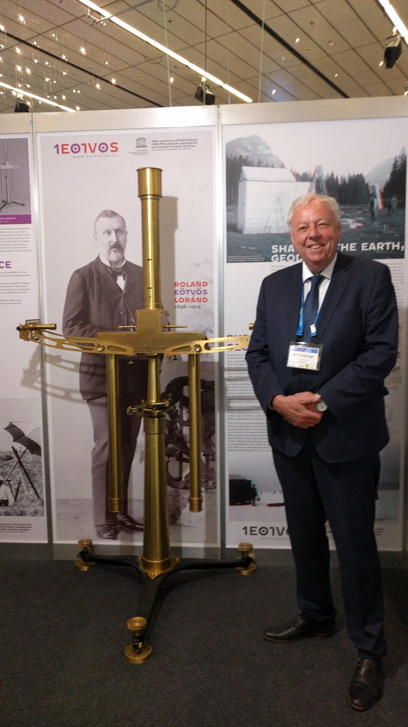
Sierd Cloetingh (at the double Eötvös torsion balance from Sopron /az Eötvös-féle soproni kettős inga mellett)

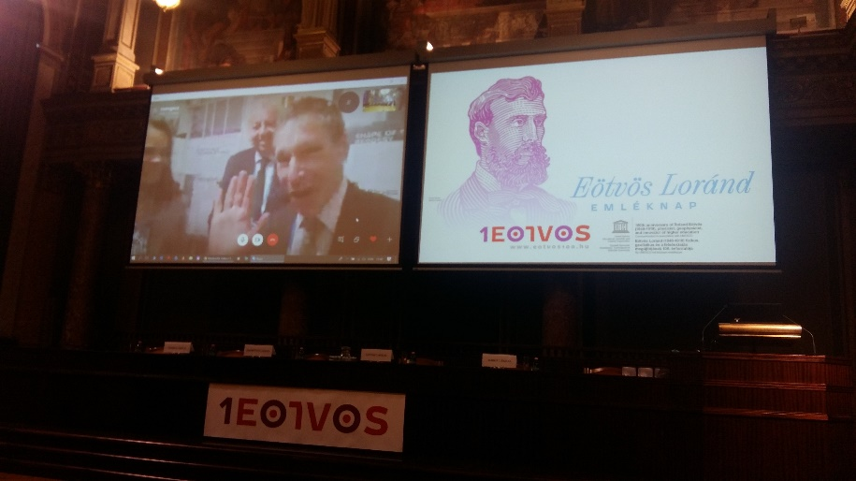
Jonathan Bamber as seen from Budapest (Budapestről nézve)

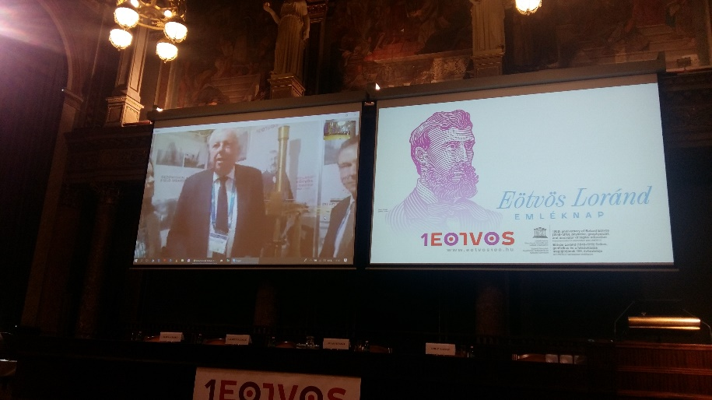
Sierd Cloetingh as seen from Budapest (Budapestről nézve)
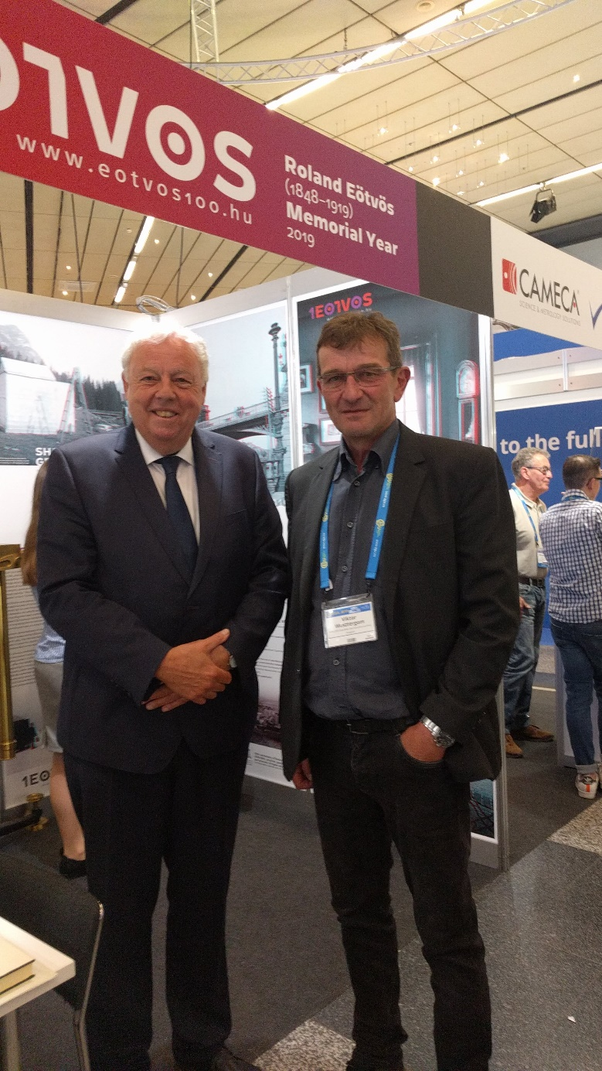
Sierd CLOETINGH and/és
WESZTERGOM Viktor (director/igazgató, MTA CSFK Geodetic and Geophysical Institute)

A kiállításon az Eötvös Loránd-sztereofotók bemutatása a Nemzeti Kulturális Alap támogatásából valósult meg. (Részletek: https://eotvos100.hu/hu/page/medias). Eredeti fotók: MBFSZ Eötvös Loránd Emlékgyűjtemény. Digitális átalakítás: Regály Zsolt (MTA CSFK). Grafika: Juhász Márton (jmdesign.hu)
The exhibition of stereoscopic photos by Roland Eötvös was supported by the National Cultural Fund of Hungary. (Details: https://eotvos100.hu/en/page/medias). Original photos: MBFSZ Eötvös Loránd Memorial Exhibition. Digital conversion: Zsolt Regály (MTA CSFK). Graphics: Márton Juhász (jmdesign.hu)

Néhány további látogató gondolatai a kiállításról:

“I was so surprized to turn the corner at EGU and find the Eotvos exhibit. I have written about Eotvos and his balance so many time but never seen the instrument. I was fun to stand next to it. I did not realize it was so tall. Thanks for bringing it to the meeting.”

Prof. Robin Elisabeth Bell (President/Elnök, American Geophysical Union)
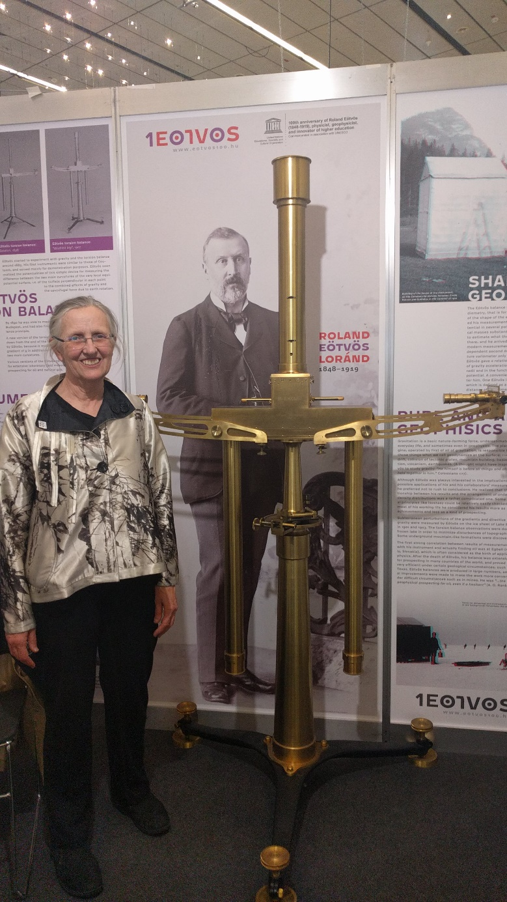
Robin Elisabeth Bell (President/Elnök, American Geophysical Union)

„As a mathematical geoscientist, I knew the name of Eötvös because of my interests in geophysical fluid and solid mechanics. The dimensionless Eötvös number correlates the gravitational and surface tension forces and used in the motion of multi-phase liquids. Actually, Roland Eötvös contributed by his exceptional studies to several fields of geodesy and geophysics, and he is indeed a great Hungarian scientist.”

Alik Ismail-Zadeh (Secretary General/Főtitkár, International Union of Geodesy and Geophysics)

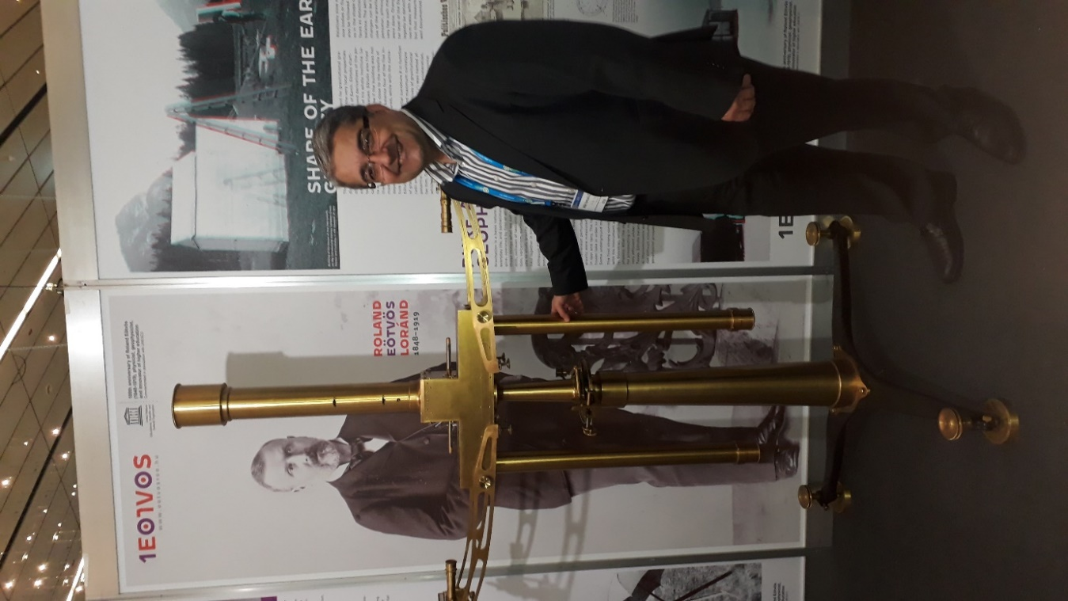
Alik Ismail-Zadeh (Secretary General/Főtitkár, International Union of Geodesy and Geophysics

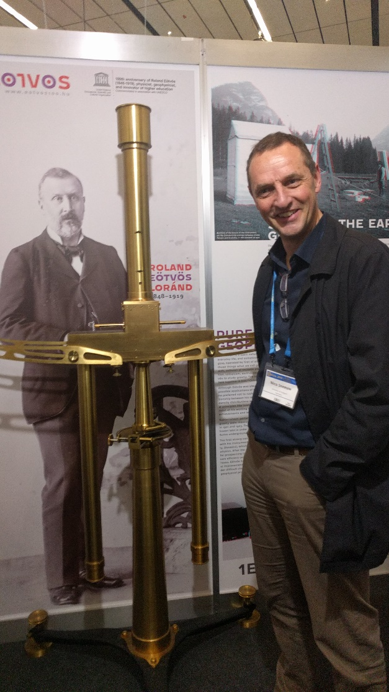 | 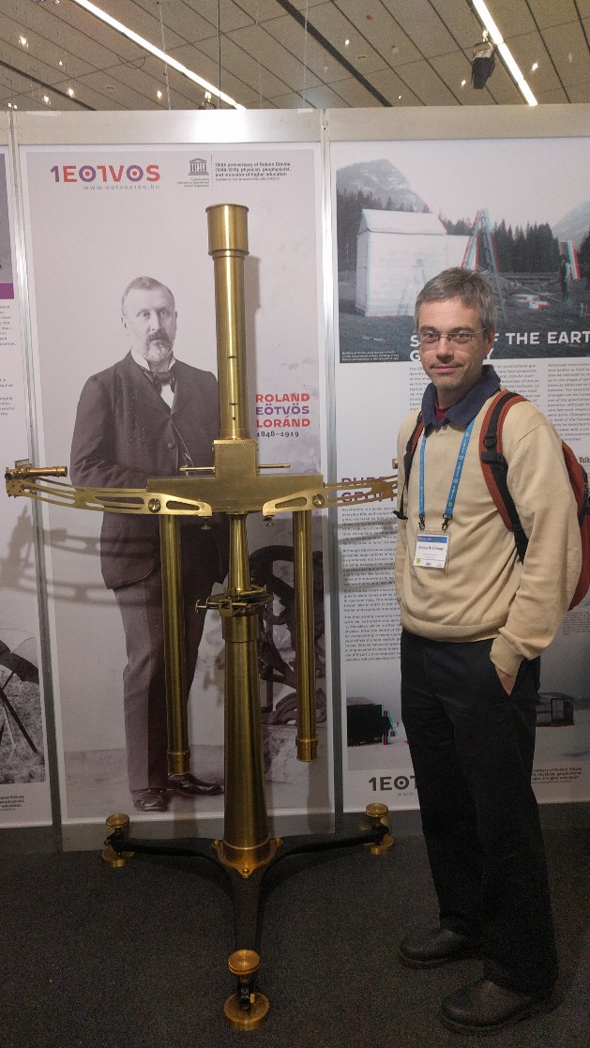
Nica Sneeuw | Frederick Simons
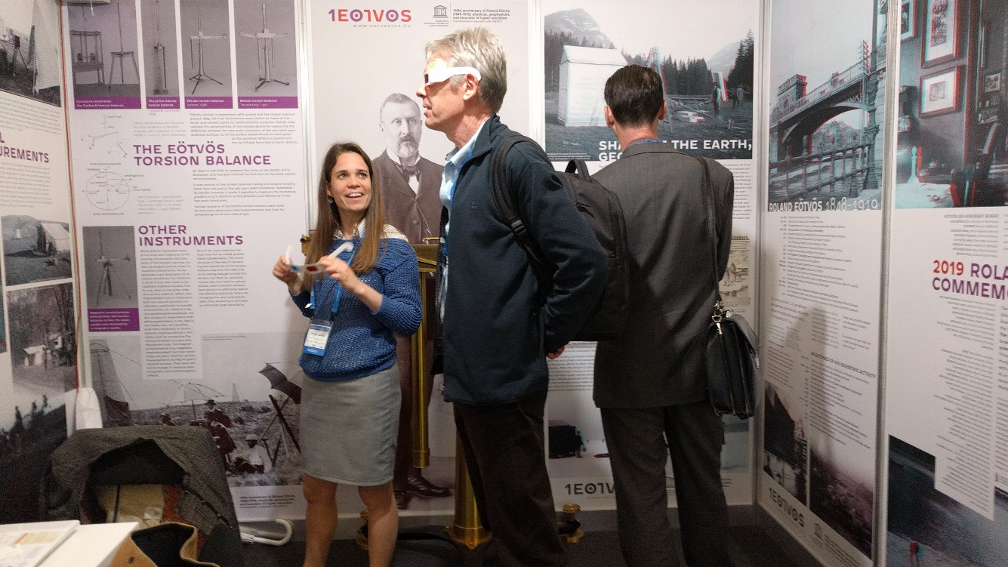
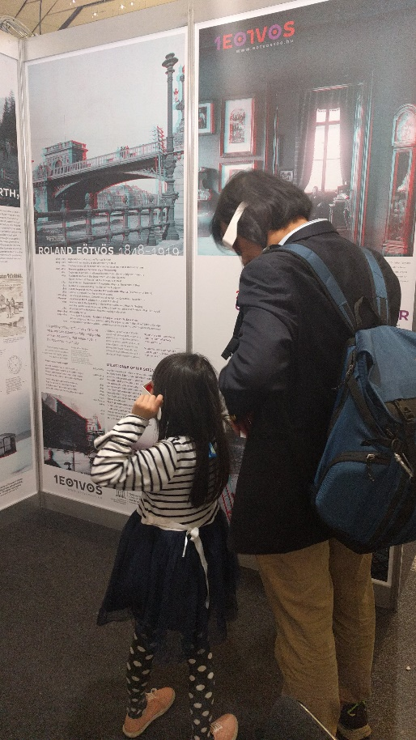 | 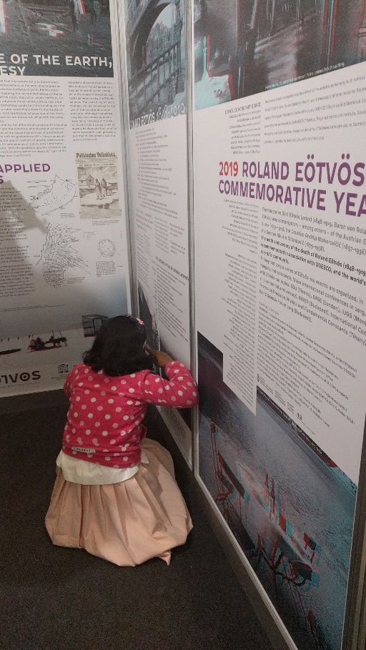

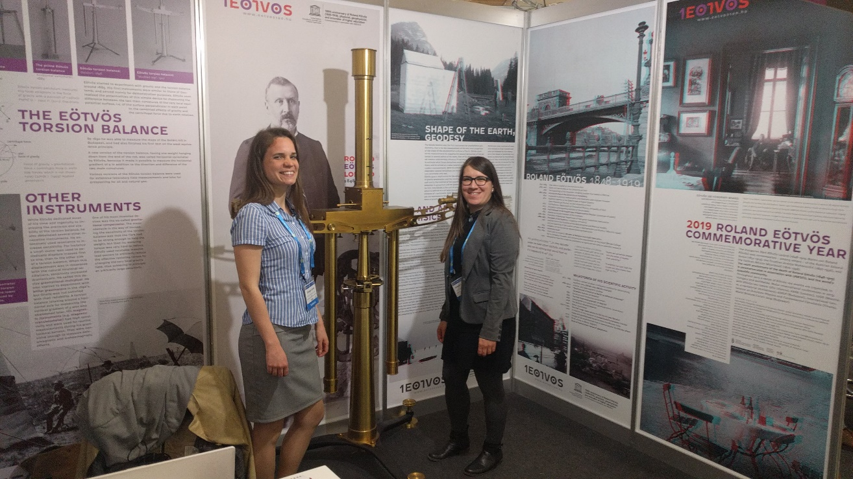
The two exhibitors: Csenge Czanik and Veronika Barta (MTA CSFK Geodetic and Geophysical Institute

Compiled by: Csenge CZANIK, Veronika BARTA (Exhibitors),
László SZARKA (Chair of Eötvös 100 Coordination Team)

Sopron, 15 April, 2019

